Determining Undervalued Airbnb Listings

Authors:

Xiaohan Xiao

Xinyue Wu

Yidi Hou

Madelyn Caufield

Abstract

Airbnb is one of the largest online marketplaces for lodging. There are two parties involved: the homeowner (host) who rents out their property to travelers, and the visitor who books stays. We gathered our data from Inside Airbnb, an independent non-commercial set of tools that provides data on listings and their associated hosts. The final dataset was a condensed version of multiple datasets on Inside Airbnb, made up of property features, host information, ratings, reviews, and availability on listings in Los Angeles. Our research question aims to determine undervalued listings. Univariate variable selection, heatmap, and PCA were used to determine the variables that were most indicative of price. We used the variables generated from each of the three methods above and ran them through an SVR model. The final result consisted of three datasets for each of the three variable selection methods showing the listings that they predicted as undervalued by comparing the predicted price to the actual listing price. In performing this analysis, one can make a better informed decision about the listing that would provide the best bang for their buck given all the amenities they desire in a property.

1. Introduction

Airbnb is an online marketplace for lodging, primarily homestays for vacation rentals and lodging. In 2008, the former “Airbed & Breakfast” (now Airbnb) website launched, creating an

online marketplace that connects homeowners (hosts) who are looking to rent out their property (listing) with customers, such as tourists or business travelers. The company grew rapidly, expanding to international markets in 2011, and first became profitable in 2016. [1] Many homeowners open up their homes for availability to Airbnb users as a way to make passive income. If an Airbnb host owns a home in a desirable vacation spot, or has a really different and unique property that’s appealing to many people, the listing could be booked most days out of the year due to high demand. There are a number of factors that could affect the price of Airbnb listings such as location, time of season, number and quality of amenities, demand, and countless others. In this report, we will describe how we estimated the effect on listing price and demand. Specifically, we will determine the most important factors that influence the price of listings and whether a listing is “undervalued”. It is important to note that unlike commercial real estate where there are external factors that affect the price of a property, Airbnb prices are determined solely by the host. This means that most listings should be appropriately priced considering the host wants people to book their Airbnb. If they want to generate steady passive income, they would put their listing at a fair market rate to ensure this. While we will still be determining undervalued listings, it is important to take this notion into consideration.

1. Data Description

The dataset we selected is downloaded from the website insideairbnb.com. It provides data that quantifies the influence of short-term rentals on the housing and residential communities. For our research project, instead of carrying out studies on all states in the United States, we picked the data that depicts the housing information in Los Angeles.

The raw files we have are about listing summary, listing details, and text reviews information. For listing summary data, there are 18 variables. 9 of them are basic information about the listing and its host. The others are population variables focusing on the total numbers and rates of reviews and room availability. For the listing detail file, there are 74 fields that cover the following aspects: basic information, availability broken down into several different periods, and reviews statistics within each month. For the review file, it only records listing id and comment contents. After cleaning and integration, we obtained 25314 unique listings with 1152450 pieces of review texts.

1. Research Methods
   1. Data Wrangling Methods
      1. Data Cleaning

The dataset is enormous, but since the NA values will impact the following modeling, we first count the NA values per column and drop the rows with all null values. Second, since we are planning to find the influencers of pricing, we should encode the string variables into categorical ones and normalize the numerical variables using min-max standardization.

* + 1. Metric Build

For the reviews in text, we use the sentiment analysis to transfer the text into three rates, which are positive rate, neutral rate and negative rate. The reason we build three rates instead of one rate is because we believe the Word of Mouth will have an impact on the listing pricing and negative comments may have stronger influence than positive rates. [3]

* + 1. File Integration

The variable ‘listing_id’ exists in all files, so we naturally use it as the primary key and merge all the files by ‘listing_id’. The joining method we utilized is the full join to make sure that every information is included before feature selection.

* 1. Metric Selection Methods

The cleaned dataset has 74 variables which definitely contain unrelated fields such as the id number of listing hosts and latitude of listing’s location. In this project, we utilize three different ways to select optimal features. They are univariate selection, correlation analysis with heat maps and PCA (Principal Component Analysis).

1. Univariate Selection

The Univariate Selection method on feature selection works by choosing the best N features based on the univariate statistical tests. We need to compare features one by one to the target field which is pricing in our project, to see the statistical significance between them. This method is also called analysis of variance (ANOVA).

The top 5 related variables are bedroom, accommodates, bathroom, beds and room types. We deduct from this conclusion that the facilities and structure of rooms are the most important aspects contributing to the final pricing in housing rental markets.

1. Correlation Analysis with heat map

The underlying logic and mathematical rule of correlation analysis is to use Pearson correlation analysis to perform pairwise statistical analysis on all fields in the data frame. The result returned by this statistical method is an N*N correlation coefficient matrix, where N is the number of columns in the data frame. The heat map uses the gradient of cool and warm tones to present the correlation coefficients more intuitively.

In this study, we use quantile numbers to select the critical value of the correlation coefficient, so as to select the independent variables whose correlation with the target field is above the critical value. The absolute value is used. Variables such as accommodates, bedrooms, beds, availability_30 and review_scores_value are among the top lists, which is consistent with the intuition mentioned above.

1. PCA (Principal Component Analysis)

PCA is one of the most popular methods in dimension reduction. The main goal of Principal Component Analysis is to simplify the numerous variables without losing important traits by finding a series of principal components. In this project, we selected 38 components which could account for over 90% of the variability of all features. The graph below shows the accumulated ability of explaining the variance of different components.

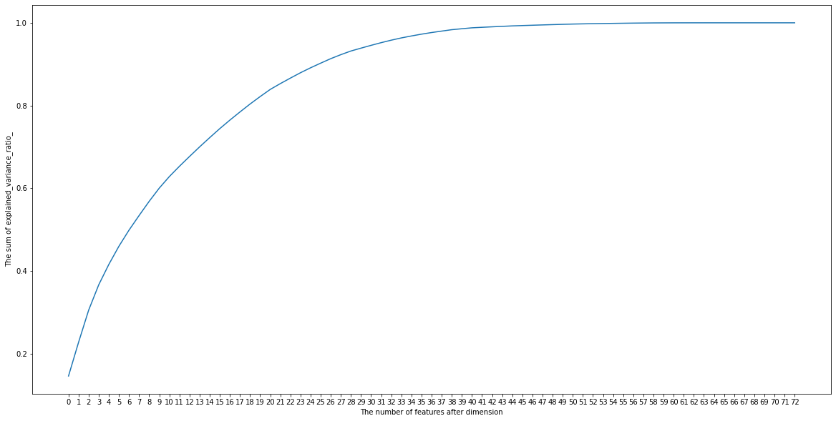

In the follow up modeling part, we use all three feature selection methods and combine them with the SVR model to do the price prediction.

* 1. Modeling Method

With the pricing variable given, our project plans to train a supervised regression model that could do predictive analysis. Our ultimate goal is to compare the predicting price with the current market price to see whether the Airbnb listing is undervalued or overvalued. Unlike the Linear Regression model whose objective is to minimize the sum of the squared errors, Support Vector Regression (SVR) only defines how much error is tolerable. So SVR has more flexibility. The parameter RBF Kernel makes it feasible to apply SVR to non-linear problems, which proves to be performing better in this project.

1. Model Results
2. Variable Selection

Through the univariate variable selection method, we obtained 15 variables which have the top 15 highest scores, and through the heatmap, we can also obtain 15 variables but with no difference from the variables selected through the univariate variable selection method. PCA is quite different from the other two methods because we can not tell the name of selected independent variables directly. Through the graph of the PCA plot, we can determine the parameters. To see which asset is being undervalued, we predict the model to get the variable named y_pred. If y_pred is larger than the original price, then we can say that the asset is being undervalued. For those being undervalued, we mark them as value 1, and the others as value 0. At last, we can obtain the id list of assets which are being undervalued.

1. Rates across Models

Two metrics we use to achieve our final goal of finding whether airbnb listing is overvalued or not are the Overvalued Rate and Undervalued Rate. They are calculated based on the comparison between predicted housing price and actual market price.

|  | |  | Univariate Selection | Heatmap | PCA | | --- | --- | --- | --- | | Undervalued Rate | 6.66% | 6.89% | 7.69% | | Overvalued Rate | 26.34% | 26.10% | 25.31% | | Total Assets | 25314 | | | | | |
| --- | --- | --- | --- | --- | --- | --- | --- | --- | --- | --- | --- | --- | --- | --- | --- | --- | --- | --- | --- |

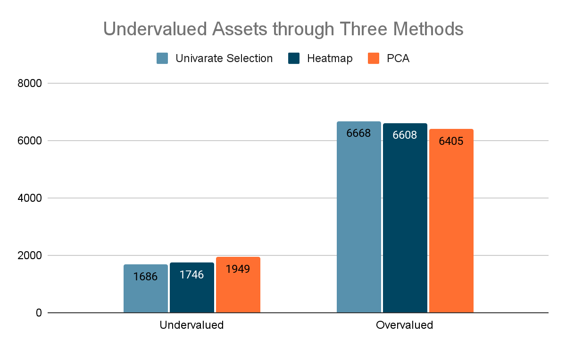

We can see that through the comparison, most of the assets are overvalued. The three methods gave us similar results, just quite a few of them are found to be undervalued, which is our main goal in this project.

1. Details of Undervalued Property in Airbnb

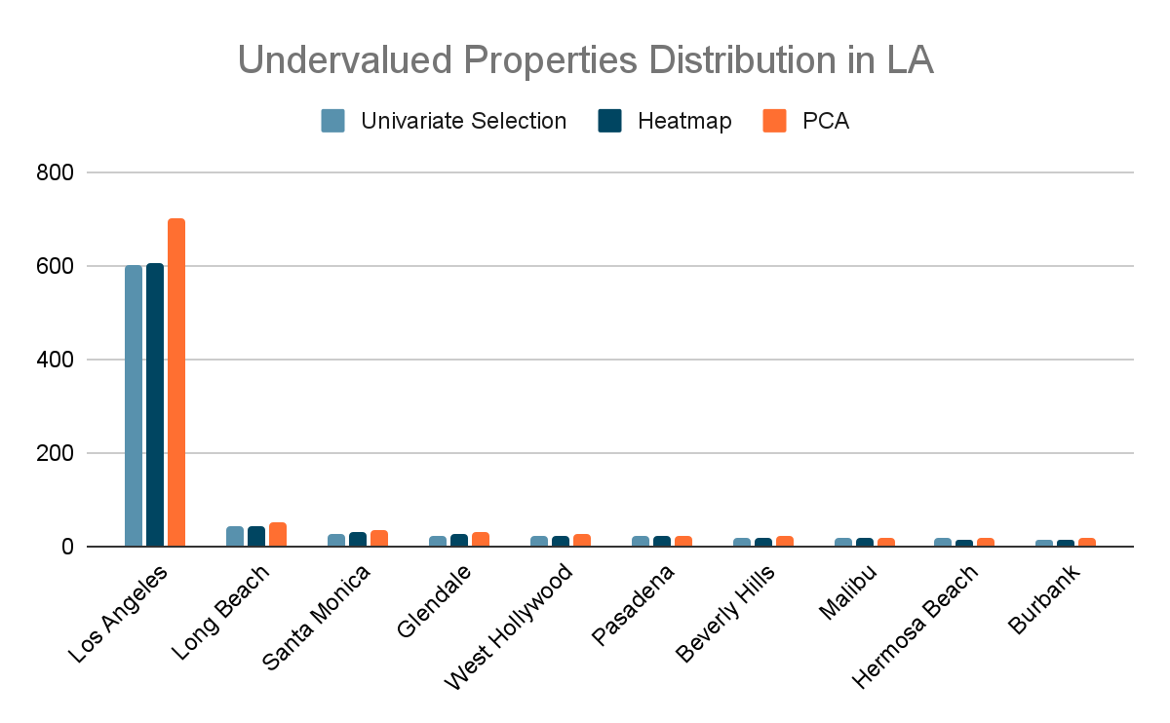

The undervalued properties have an apparent geographical distribution that is even half of the undervalued properties located in Los angeles. The rest properties are distributed evenly among other areas. The geographical distribution of undervalued listings can be further depicted in the following maps. The orange spots have more airbnb listings than the green spot and these orange clusters are located in Los Angeles.

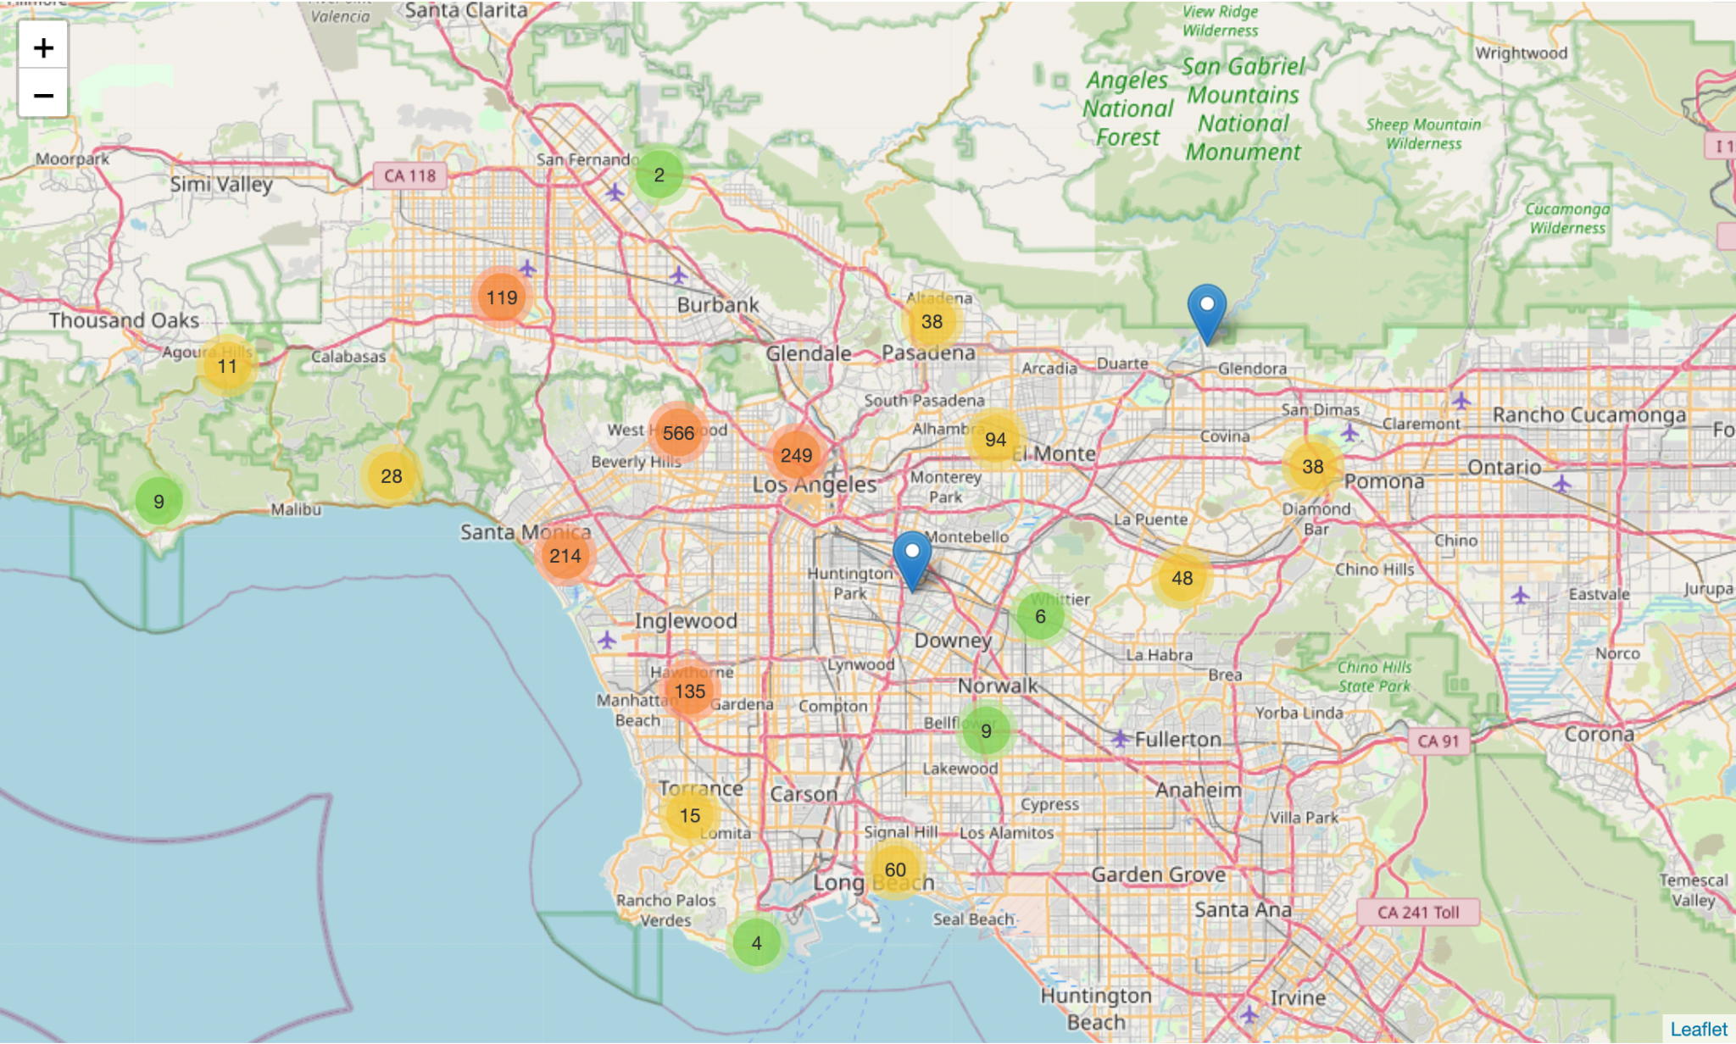

Undervalued Properties Distribution in LA using univariate selection

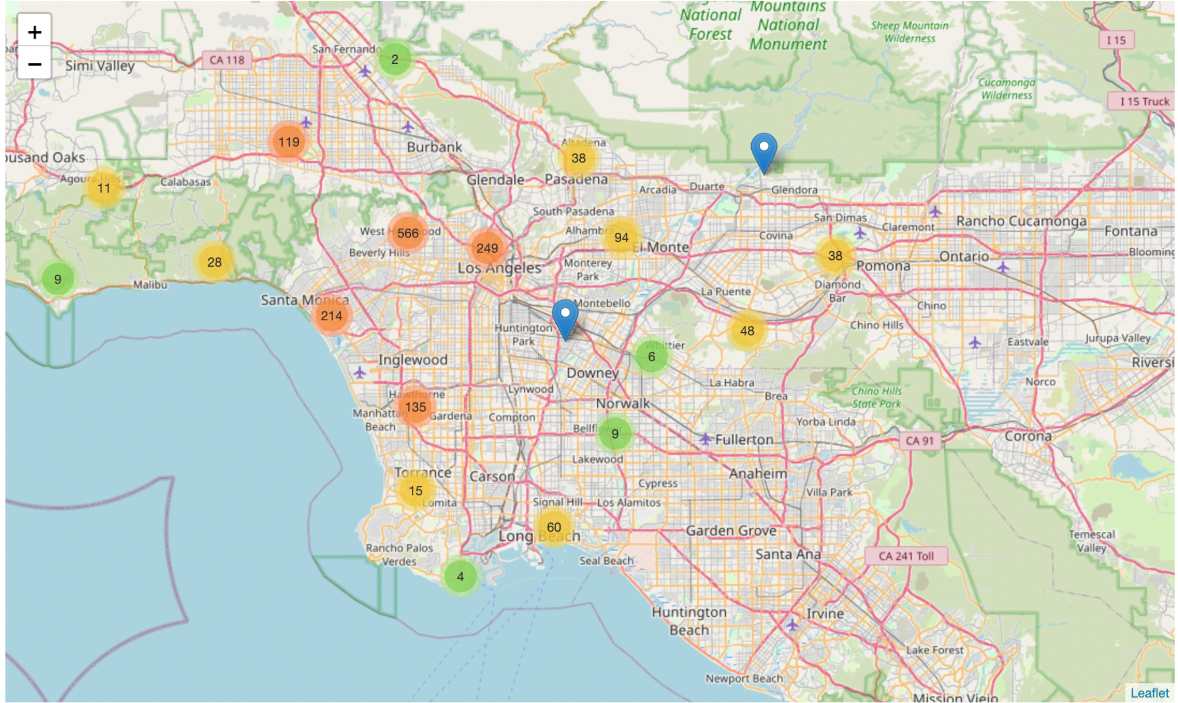

Undervalued Properties Distribution in LA using Heatmap

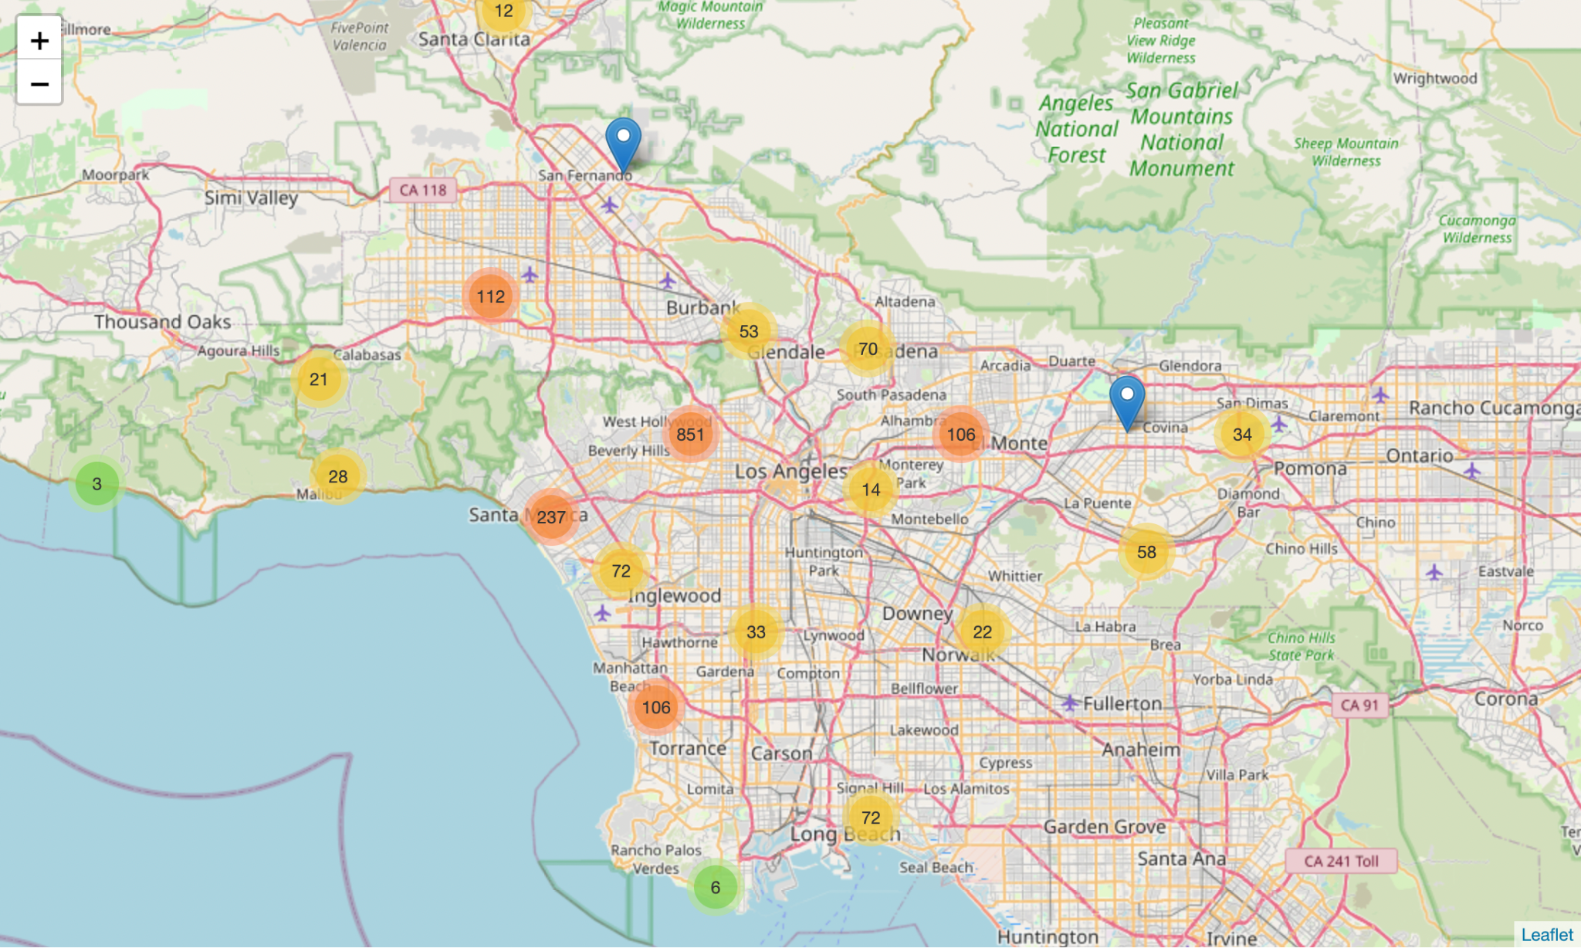

Undervalued Properties Distribution in LA using PCA

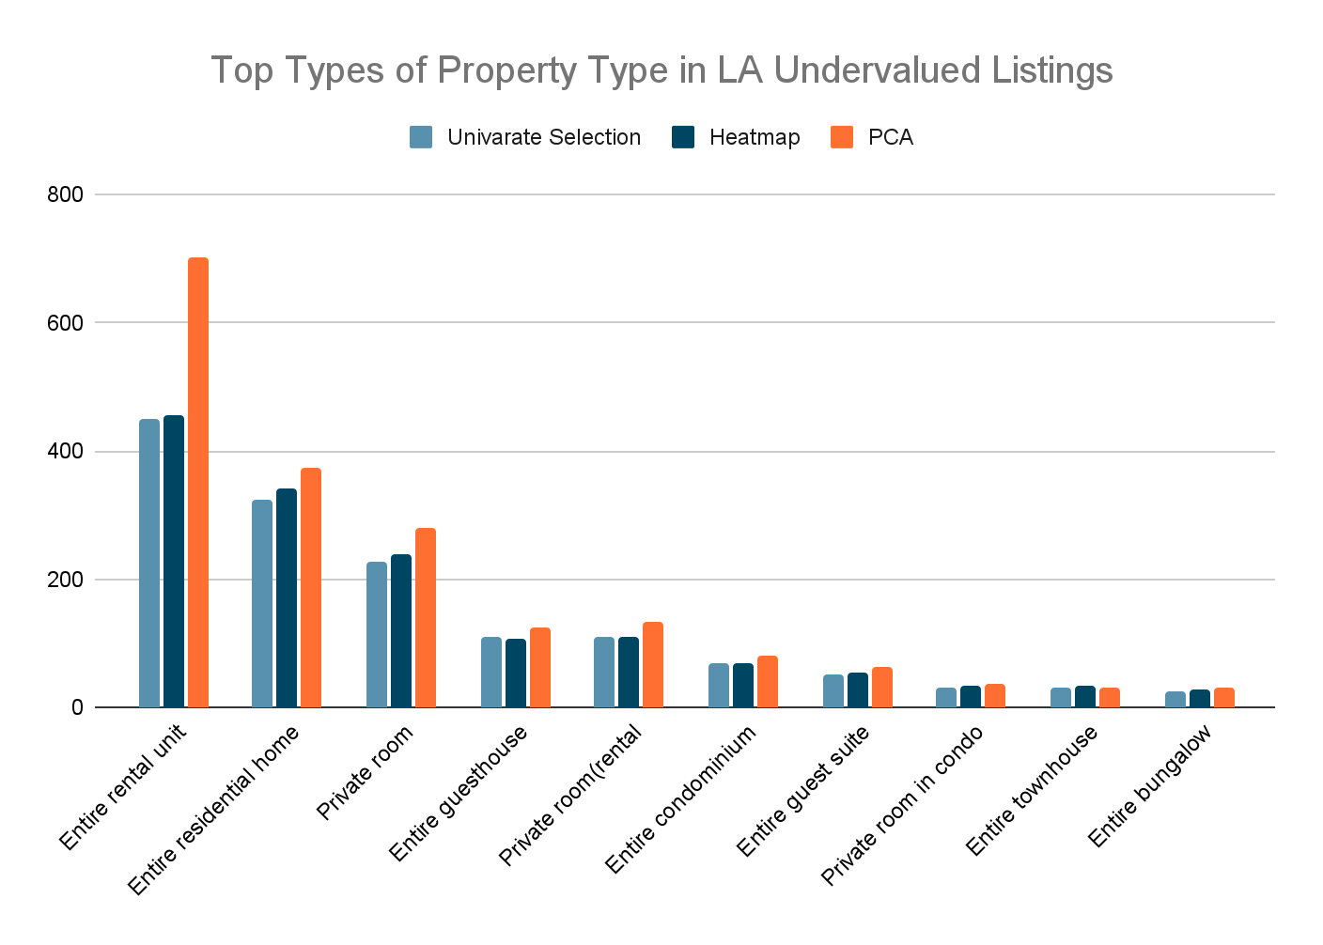

When it comes to the property type, the airbnb listing of entire rental units accounts for the majority of undervalued properties. Entire residential home comes second. This may be due to the lack of price advantage of entire rental properties in the rental market. Even with more complete structures and facilities, the owner of the house has to post it on airbnb at a price lower than the actual value of the house.

1. Discussion

The current report aims to analyze the effects on Airbnb listing price and determine properties that are deemed ‘undervalued’. ‘Undervalued’ here is defined as properties whose predicted price is higher than the actual price. To accomplish this, we performed three variable selection methods: univariate variable selection, heatmap, and pca. A support vector regression (SVR) was performed three times using the variables from each of the three variable selection methods. The output of the models consisted of a dataset showing the predicted price, actual price, and binary label describing whether the listing is undervalued or not.

This could be useful to Airbnb users who are looking to find stays that will give them the best property for the lowest price. If the Airbnb user was a data scientist, they could narrow down the criteria for the Airbnb they want to stay at, find the property that meets all their standards, and choose the Airbnb that is the lowest price, knowing that they are getting the best possible deal. While it is possible to adjust many of these features on the Airbnb website, there are additional factors used to determine prices that are otherwise hidden to users of Airbnb.com.

Model enhancement and demand forecasting based on yearly historical data could be done in the future, taking seasonality, holidays, and trends into account. Other future work could include location analysis using Google Maps Geocoding API. Additional information on demand and pricing can be gained by examining location and assigning categorical values to listings that are located near a prominent landmark or attraction. There are a number of things one could do with the data provided on Inside Airbnb, and while the current project barely scratches the surface, it can be useful in understanding what features drive price, and how much that price can vary from expected price given the property features.

1. References

[1] Stone, Brad and Olivia Zaleski. 2017. “Airbnb Enters the Land of Profitability.” Bloomberg, January 26, 2017.

<https://www.bloomberg.com/news/articles/2017-01-26/airbnb-enters-the-land-of-profitability>.

[2] <http://insideairbnb.com/about.html>

[3] [Sweeney, J.](https://www.emerald.com/insight/search?q=Jill%20Sweeney), [Soutar, G.](https://www.emerald.com/insight/search?q=Geoff%20Soutar) and [Mazzarol, T.](https://www.emerald.com/insight/search?q=Tim%20Mazzarol) (2014), "Factors enhancing word-of-mouth influence: positive and negative service-related messages", [European Journal of Marketing](https://www.emerald.com/insight/publication/issn/0309-0566), Vol. 48 No. 1/2, pp. 336-359. <https://doi.org/10.1108/EJM-06-2012-0336>